A

**MINOR PROJECT REPORT ON**

**“CET MANAGEMENT SYSTEM”**

Project Report Submitted in partial fulfilment for the

Award of degree of

**MASTER OF COMPUTER APPLICATIONS**

*Under the esteemed guidance of*

**Prof. G.ANJANBABU**

**M.Sc., M.Tech., Ph.d**



Submitted By:

**PREMANATH.T (60117163)**

**VENKATESU.V (60117208)**

DEPARTMENT OF COMPUTER SCIENCE

COMMERCE MANAGEMNET AND COMPUTER SCIENCE

**SRI VENKATESWARA UNIVERSITY**

**TIRUPATHI -517502**

**(2017-2020)**

A

MINOR PROJECT REPORT ON

**“CET MANAGEMENT SYSTEM”**

Project Report Submitted in partial fulfilment for the

Award of degree of

**MASTER OF COMPUTER APPLICATIONS**

*Under the esteemed guidance of*

**Prof. G.ANJANBABU**

**M.Sc., M.Tech., Ph.d**



Submitted By:

**PREMANATH.T (60117163)**

**VENKATESU.V (60117208)**

**Submitted To:**

**Project Guide** **Head of the Department**

**(Dr. G ANJANBABU Sir)**   **(Dr. S Ramakrishna Sir)**

DEPARTMENT OF COMPUTER SCIENCE

COMMERCE MANAGEMNET AND COMPUTER SCIENCE

S V UNIVERSITY C M & CS – Tirupathi

**DEPARTMENT OF COMPUTER SCIENCE S.V.U COLLEGE OF COMMERCE MANAGEMENT AND COMPUTER SCIENCE**

**SRI VENKATESWARA UNIVERSITY**

**TIRUPATHI -517502**

**2017-2020**

**CERTIFICATE**

This is to Certify that the Project titled **“CET MANAGEMENT SYSTEM”** Is a Bonafide work carried out by **Talamarla Premanath (60117163),V Venkatesu (60117208)** of Sri Venkateswara University, Tirupathi, for the award of **MASTER OF COMPUTER APPLICATIONS** is a record of bonafide minor project work carried out by the candidates under my supervision and Guidance. The minor project has reached the standard fulfilling the requirements of the regulation and guidance. The minor project has reached the standard fulfilling the requirements of the regulation for the award of the degree of  **SRI VENKATESWARA UNIVERSITY.**

**PROJECT GUIDE HEAD OF DEPARTMENT**

**Prof. G.ANJANBABU Prof.S.RAMAKRISHNA**

**M.Sc.,M.Tech., Ph.D M.Sc. M.Phil., M.Tech.,Ph.D**

**Dept. of Computer Science Dept. of Computer Science**

**S.V University, Tirupathi S.V University, Tirupathi**

**Examiner**

**Submitted for the practical Examination Held On :……………………………………**



**PREFACE**

This Project **“CET MANAGEMENT SYSTEM ”** provides a simple Online Education Portal CET MANAGEMENT SYSTEM that allows Students to communicate to communicate with one another, view Class Videos and Materials, interact or Videos, Easy Interact With Faculty’s.

Classroom allows both learners and instructors around the world to participate in live classes to collaborate and interact. MOOC Programs Like Coursera and NPTEL are a great example of this concept in action.

Online Classes also allow for the ability to record class as it happens, including any presentation audio and visuals. This means that the content is accessible even after being delivered, an added benefit for those who want a quick refresher, or perhaps did not fully understand the first time.



**ACKNOWLEDGEMENT**

We take this opportunity to express our sincere gratitude to all those who helped us in various capacities in undertaking this project and devising the report.

We are privileged to express our sense of gratitude to our respected Faculty **Dr. G Anjanbabu Sir** whose unparalleled knowledge, moral fibber and judgment along with his know-how, was an immense support in completing the project.

We are also grateful to **Dr. S Ramakrishna Sir,** the Head of Department, MCA Dept., for the brainwave and encouragement given.

We take this opportunity also to thank our friends and contemporaries for their co-operation and compliance.

**Premanath T**

**Venkatesu V**

**Chinna G**

**TABLE OF CONTENTS**

|  |  |  |
| --- | --- | --- |
| **S.No** | **Title** | **Page No.** |
| 1. | 1.Introduction | 2 |
| 2. | 2 Synopsis of Project | 3 |
| 3. | 3 Software Requirement Specification  3.1 Hardware Requirements  3.2 Scope  3.3 Definitions | 4  5 |
| 4 | 4 Technologies | 6 |
| 5 | 5 Overall Description  5.1 User Classes and Charactestics  5.2 Operating Environment  5.3 Use Case Models  5.4 Specific Requirements | 7 |
| 6 | 6 Design Phase | 18 |
| 7 | 7 Technologies Overview | 24 |
| 8 | 8 Project Description | 30 |
| 9 | 9 Source code | 34 |
| 10 | 10 Screenshots | 79 |
| 11 | Scope of the Project | 83 |
| 12 | Bibliography | 84 |

**Introduction**

**Abstract**

“ONLINE CLASS ROOM” Learning is learning utilizing electronic technologies to access educational curriculum outside of a traditional classroom.  In most cases, it refers to a course, program or degree delivered completely online.

There are many terms used to describe learning that is delivered online, via the internet, ranging from Distance Education, to computerized electronic learning, online learning, internet learning and many others. We define this project as courses that are specifically delivered via the internet to somewhere other than the classroom where the professor is teaching. It is not a course delivered via a DVD or CD-ROM, video tape or over a television channel. It is interactive in that you can also communicate with your teachers, professors or other students in your class. Sometimes it is delivered live, where you can “electronically” raise your hand and interact in real time and sometimes it is a lecture that has been pre-recorded.

There is always a teacher or professor interacting /communicating with you and grading your participation, your assignments and your tests. Online Learning has been proven to be a successful method of training and education is becoming a way of life for many citizens in North Carolina.

There have been many studies showing that eLearning students retain the material to a significantly greater degree than face-to-face instructor led classes. The content delivery is consistent and can be easily repeated if needed to gain a better understanding

**Synopsis of Project**

**Name of the Project:** CET MANAGEMENT SYSTEM

**Objectives:**

* help define your eLearning course
* help keep your planning eLearning strategies on track
* be in line with educational philosophy
* help define your eLearning assessment
* tell the learner exactly what to expect

**User Views :**

* Admin as HOD /Faculty
* Student

**Platform**

**Operating Systems:**

* Microsoft Windows

**Technologies used:**

* Front End : HTML, CSS and JavaScript
* Web Designing Language : PHP
* Back End : MySQL

**Software Requirements:**

* PHP 7.0
* APACHE HTTP Server
* Brackets
* Microsoft Windows or Linux

**Hardware Requirements:**

* Intel i3 Processor or Equivalent or Higher
* 1 GB Ram or Higher
* 200 GB HDD or higher
* Network Connectivity

**SOFTWARE REQUIRMENT SPECIFICATION**

**Hardware Requirements:**

**Purpose :**

The Objective of **CET MANAGEMENT SYSTEM** is to allow utilizing electronic technologies to access educational curriculum outside of a traditional classroom and the administrator of any organization to edit and find out the student data and allows the student to keep up to date his profile. It’s also facilitate keeping all the records of students, such as their id,name,email,address,phone etc. So all the information about an student will be available in a few seconds.

Overall, it’ll make Online Class Room an easier to delivery the Classroom Curriculums.

The main Purpose of this SRS document is to illustrate the requirements of the project **Online Class Room** and is intended to help any School/College Institutions and manage their students.

**Scope :**

Without a **Online Class Room** , managing and maintain the Course content for the student is a tedious job for any institute.

**Login Module:** Login Module will help in authentication of user accounts users who have login id and password can only login into their respective accounts.

**Registration Module :** This Module will help the Student get registered from anywhere if internet is present. This module will really simplify the task of on paper registration. Also after successful registration the user update information and change their password as and when required.

**Upload Management :** This module will help the Faculty/Hod in enabling/diabling a student account and updateing user information as required.

Purpose of project is to maintain Class information/data/material to the students such as stroing information about.

* All Students Data
* Student Data Edit
* Student Data Delete
* Upload Videos
* Material Upload
* Time Table Upload
* Student Registration
* Student Login

**Definitions, Acronyms and Abbreviations:**

**Student Details :** Details of Student such as Student name, admission Number, batch Year, email id, password ,phone number, address etc.

**Contact Details :**Details of contact associated with the student and Faculty with CET MANAGEMENT SYSTEM.

**SRS :** System Requirement Specification

**WWW :** World Wide Web

**Faculty Login :**  A Login Id repressing and Control over the all The Students and Uploading Videos, Material and Timetable etc. This user is an Administrator & can access all the records details.

**Technologies :**

* PHP
* MYSQL
* JAVASCRIPT
* HTML
* CSS

**Overview:**

The rest of this SRS is organized as follows:

**Section 2** gives an overall description of the software. It gives what level of proficiency is excepted of the user, some general constraints while making the software.

**Section 3** gives specific requirements which the software is expected to deliver. Some performance requirements and constraints are also given and deal with other Non-Functional Requirements.

**Section 4** deals with External Interface Requirements like Hardware and Software Interface.

**OVERALL DESCRIPTION**

**Product Perspective:**

The website **CET MANAGEMENT SYSTEM** is aimed towards recording a considerable number of student records and needs online assistance for managing records of students and Uploading Video Classes and Materials. Website should be user-friendly, ’quick to learn’ and reliable website for the above purpose.

**CET MANAGEMENT SYSTEM** is intended to be a stand-alone product and should not depend on the availability of other website. The system will also have an administrator who has full-fledged rights with regards o performing all actions related to control and management of the website.

**Product Functions:**

The are two different users who will be using this Project:

* Faculty Login who can Upload Material and Video and Timetable, View and Edit the details of any Students of any Students.
* Students who can view their details as well as they can also Use Uploaded Videos or Material Or Timetables and as well as they cab edit their details.

**The Features that are available to the Faculty Login are :**

* Faculty can login into the system and perform any of the available operations.
* Can Enable/Delete Student.
* Can Edit Student information to the database.
* Can Make Upload Video Content Classes.
* Can Upload Material like PDF, Word Etc.
* Can Access all the details of the student.

**The features that are available to the Student are :**

* Student can Login into the system and can perform any of the available operations.
* Can view his/her personal details.
* Can edit his /her personal details.
* Can Register their data.
* Can Access Faculty provided Data.

**User Classes and Characteristics :**

There are Mainly two kinds of users for the project

The Users Include :

Faculty

Student

**Operating Environment :**

The Project can run on any Browser.

**Constraints :**

* Every user must be comfortable using computer.
* All operations are in English so user must have basic knowledge of English.

**Use Case Model :**

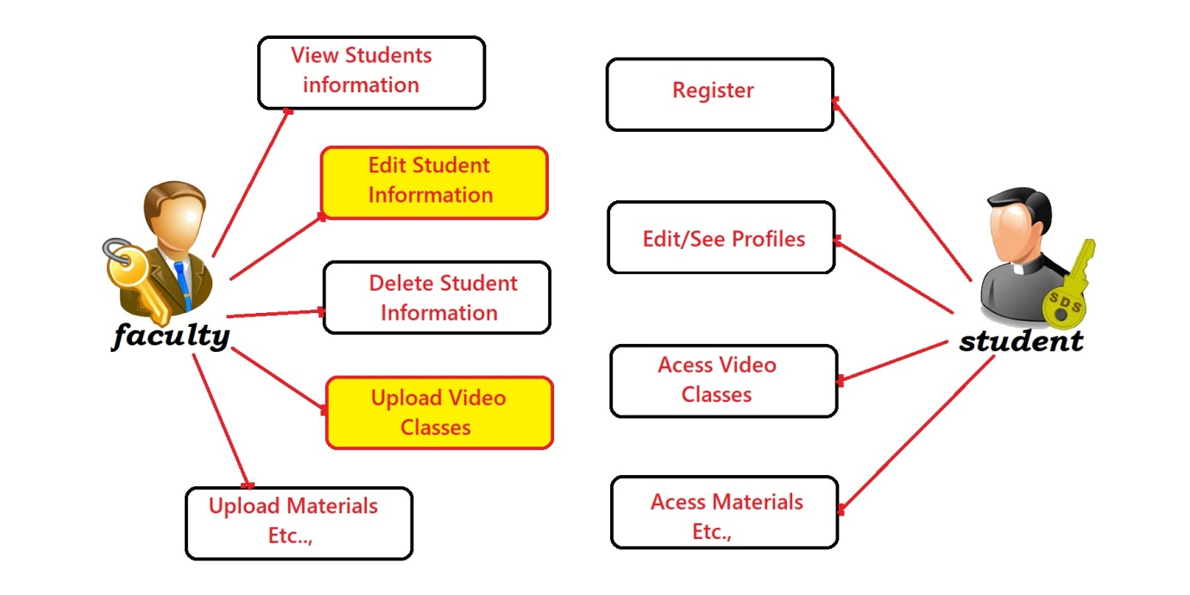

**Fig 4.1 Use Case Model**

**1.Faculty :** Responsible for managing student records and Uploading Classes.

* Login into the Website
* Update Student Details
* Delete Student Details
* Display All Student Details
* Upload
* Videos
* Materials
* Pdf, Time Tables..etc.,

**2.Student :**  Has the Access rights to view and edit their personal details, and View the Admin Videos and Materials.

* Login into the website
  + Display Student Data
  + Edit Student Data
  + Access Uploaded Videos
  + Access Uploaded Materials etc.,

**Assumptions & Dependencies**

* Faculty is created in the system already.
* Roles and tasks are predefined.

**Specific Requirements :**

**Use Case Reports**

**1.Faculty :**Responsible for managing student details and Uploaded Contents.

**Use case :**Login into the website

**Goal in Context:** Gain Access to the website

**Brief Description :**This use case is used when the administrator wants to access the website to upload The Videos/Material/Content and View/Edit/Delete the personal details of the Student.

**Preconditions :** The Faculty must be logged onto the website in order for this use case to begin.

**Basic Flow:**

* The website prompts the administrator for the username and password.
* The faculty enter the user name and password.
* The website verifies the password and sets the user’s authorization.
* The faculty is given access to the website to perform his tasks.

**Alternative Flow:**

* The faculty enters invalid username and password then he will not be allowed to enter the website.

**Post conditions:** The website state is unchanged by this use case

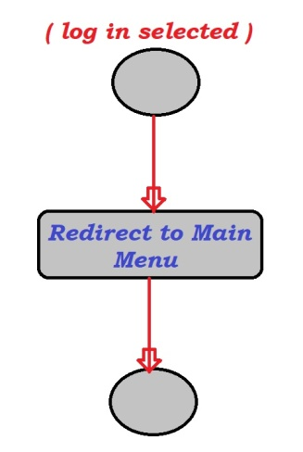

**Fig 4.2 Use case report-Login into the website**

**Use case :** Display student details

**Goal in context :** View the details of a student

**Brief Description :** This use case is used when the faculty wants to view the personal details of the students already existing in the database on the screen.

**Preconditions:**

* The faculty Must be logged into the system in order for this use case to begin
* The Details of the student must pre-exist in the database
* The student admission number must be entered correctly.

**Basic Flow:**

* The Faculty logs onto the System
* The Faculty Upload The Following Contenst
  + Videos
  + PDF
  + WORD
  + Matrilas
* The System prompts for the student from one of the above keys.
* The student details are displayed on the screen.

**Alternative Flow:**

Student Not Found

If in the **Display a Student** sub-flows, a student with the specified admission number does not exist, The system displays an error message. The Faculty can then enter a different id number or cancel the operation,at which point the use case ends.

**Post Conditions:**

The Student details are displayed on the screen already existing in the system. The State of the System remains unchanged.

**Basic Flow :**

* The Faculty logs onto the system
* The Faculty can edit following keys:
  + Student name
  + Admission no
  + Batch year
  + Email id
  + Password
  + Phone no
  + Address
* The Website updates the database according to edited details.
* The student details are edited in the database.

**Alternative Flow:**

There is no alternative flow of this use case diagram.

**Post Conditions :**

The Student details get updated in the database.



**Fig 4.3 Edit Student Details into the website**

**Student**

**Use Case:** Student Registration

**Goal In Context:** Registration of a student

**Brief Description :** This use case is used when the student register himself/herself in the database online.

**Pre conditions :**

* The Student must accessed the website in order for this use case to begin.
* The user id must be unique and entered correctly.

**Basic Flow:**

* The Student enters into website.
* The student fill his her details from the following keys :
  + Student name
  + Admission no
  + Batch year
  + Email id
  + Password
  + Phone number
  + Address
* The system details are added to the database
* The student details are displayed on the screen.

**Alternative Flow:**

User id not unique: if the user id entered is not unique then it will show an error message.

**Post Conditions :**

The student get registered on the website and to login into that particular the administrator must enable it.



**Fig 4.3**

**Use-case :** Login Into the Website

**Goal in Context:** Gain access to the website

**Brief Description:** This use case is used when the student wants to access the website

**Preconditions :** The Administrator must enabled the particular student onto the website in order for this use case to begin.

**Basic Flow:**

* The website prompts the students for the username and password.
* The student enters the username and Password
* The Website verifies the password and sets the user’s authorization.
* The student is given access to the website to perform his tasks.

**Alternative Flow :**

* The Student enters invalid username and password then he will not be allowed to enter the website.

**Post Conditions:** The Website State is Unchanged by this use case.



**Fig 4.4**

**Use case:** Edit Student Details

**Goal in Context:** Edit the details of a student

**Brief Description :** The use case is used when the student wants to edit the personal details of the himself already existing in the database.

**Preconditions:**

* The Student must be logged into the system in order for this use case to begin.
* The details of the student must pre-exist in the database
* The student must be enabled by faculty

**Basic Flow:**

* The Student logs onto the system
* The student can edit following keys
  + Student Name
  + Admn Number
  + Batch Year
  + Email Id
  + Password
  + Phone Number
  + Address
* The website updates the database according to edited details
* The student details are edited in the database

**Alternative Flow:**

There is no alternative flow of this use case diagram.

**Post Conditions :**

The Student details get updated in the database.



**Fig 4.5 Use Case Model**

**Functional Requirements:**

* The Faculty will be given more powers(edit/update) than other users.
* It will be ensured that the information entered is of the correct format.For example name cannot contain numbers. In case incorrect form of information is added, the user will be asked to fill the information again.
* The system can be accessed anytime.

**Non-Functional Requirement:**

**Performance Requirements:**

The proposed system that we are going to develop will be used as the Cheif performance system for providing help to the organization in manageing the whole database of the student studying in the organisation.Therefore, it is expected that the database would perform functionally all the requirements that are specified.

**Safety Requirements :**

The database may get crashed at any certain time due to virus or operating system failure. Therefore, it is required to take the database backup.

**Security Requirements:**

We are going to develop a secured database. These are different categories of users namely Administrator, Student who will be viewing either all or some specific information from the database.

Depending upon the category of user the acess rights are decided.it means if the user is an administrator then he can able to modify the data, appemd etc., all other users only have the rights to retrieve the information about database.

**Conclusion:**

The SRS has given all the details of the application need to be built.

**DESIGN PHASE**

**Introduction**

**Scope and Purpose**

The purpose of the design phase is to develop a clear understanding of what the developer want people to gain from his/her project. As you the developer work on the project, the test for every design decision should be “Does this feature fulfil the ultimate purpose of the project?”

A purpose statement affects the design process by explaining what the developer wants the project to do, rather than describing the project itself.

The design Document will verofy that the current mets all of the explicit requirements contained in the system model as well as the implicit requirements desired by the customer.

**Overall System Design Objectives**

The overall system design objective is to provide an efficient, modular design that will reduce the system’s complexity, facilitate change and result in an easy implementation. This will be accomplished by designing strongly cohesion system with minimal coupling. In addition,This document will provide interface design models that are consistent user friendly and will provide straight forward transition through the various system functions.

**Structure of Design Documnet**

* System Architecture Design – The system architecture section has detailed diagram of the system,server and client architecture.
* Data Design – The Data design include an ERD as well as Databse design.
* Functional Design Description – This section has the financial partitioning from the SRS, and goes into great detail to describe each function.

**System Architecture Design**

**System Architecture**

The CET MANAGEMENT SYSTEM is a system with contain major part which include: Student Detail,Acess Faculty Material Content.

The user selects one of the available options as an input to the system. According to the input by the user the system acts and the rest of the functions are performed accordingly. The faculty can operate on any student details. But the normal student or users can only access their details of all the functionalities.

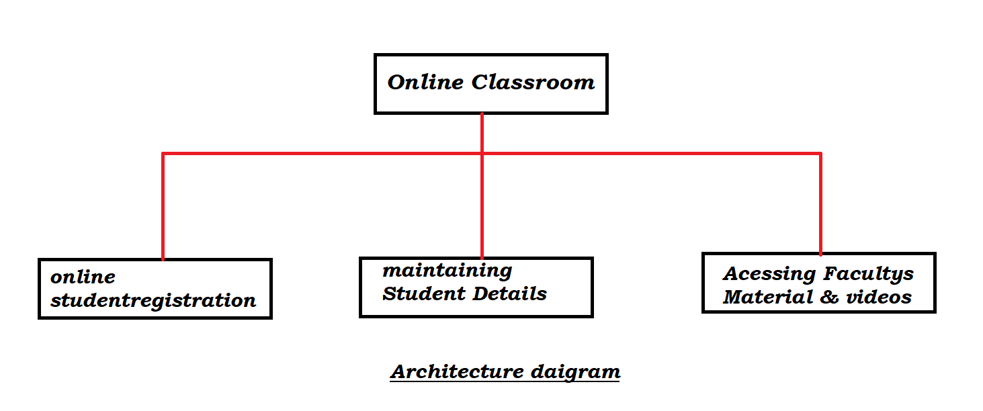

**Fig 5.1**

**Data Design**

**Entity Relationship Diagram:**

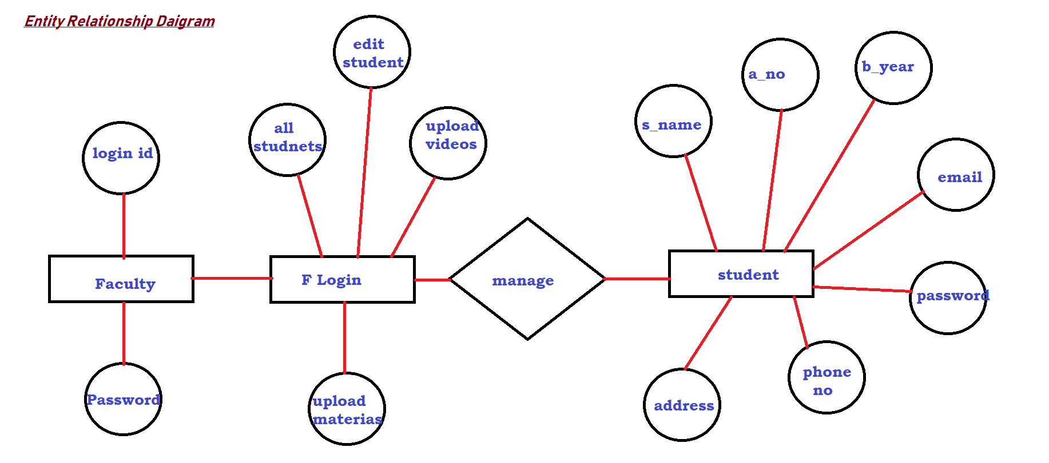

**Fig 5.2**

**Functional Design Description**

**Data Flow Diagram:**

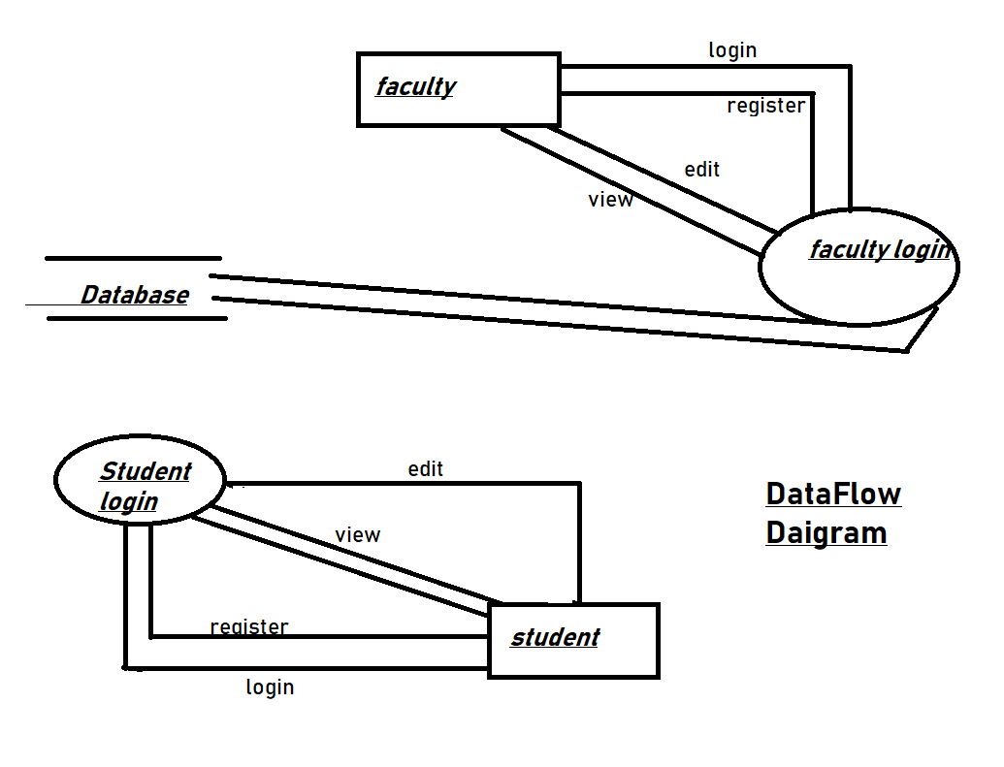

**Fig 5.3**

**Decision Tree:**

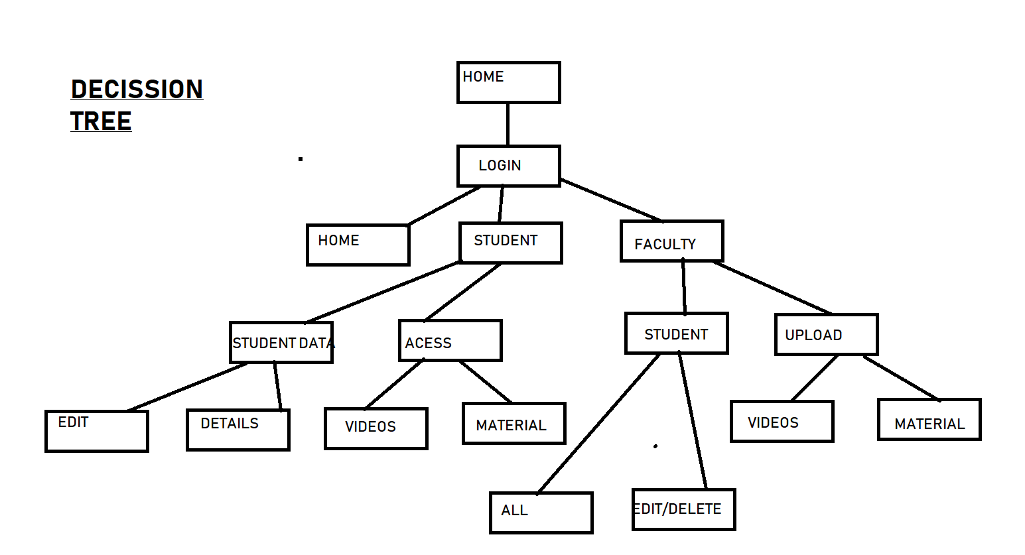

**Fig 5.5**

**Conclusion**

Hence we can conclude that the design phase of the CET MANAGEMENT SYSTEM five us the information of all the process used in the project and their relation.

**Technology Overview**

The technology selected for implementing CET MANAGEMENT SYSTEM System is PHP/MYSQL Apache is used as the HTTP Server. The Development was done in a ‘windows’ environment using adobe Dreamweaver CS5/Brackets.

**PHP**

PHP is a general-purpose scripting language that is especially suited to server side web development where PHP generally runs on a web server.PHP code is embedded into the HTML source document. Any PHP code in a requested file is executed by the PHP runtime, usually to create dynamic web page content. It can also be used for command-line scripting and client-side GUI applications. PHP can

be deployed on many web servers and operating systems, and can be used with many relational database management systems (RDBMS). It is available free of charge, and the PHP Group provides the complete source code for users to build, customize and extend for their own use.

**MySQL**

MySQL is a relational database management system (RDBMS)that runs as a server providing multi-user access to a number of databases. MySQL is a popular choice of database for use in web applications and is an open source product. The process of setting up a MySQL database varies from host to host, however we will end up with a database name, a user name and a password. Before using our database, we must create a table. A table is a section of the database for storing related information. In a table we will set up the different fields which will be used in that table. Creating a table in php MyAdmin is simple; we just type the name, select the number of fields and click the ‘go’ button. we will then be taken to a setup screen where you must create the fields for the database. Another way of creating databases and tables in php MyAdmin is by executing simple SQL statements. We have used this method in order to create our database and tables.

**Apache**

The Apache HTTP Server is web server software notable for playing a key role in the initial growth of the World Wide Web. In 2009 it became the first web server software to surpass the 100 million web site milestone. Apache is developed and maintained by an open community of developers under the auspices of the Apache Software Foundation. Since April 1996 Apache has been the most popular HTTP server software in use. As of November 2010 Apache served over 59.36% of all websites and over 66.56% of the first one million busiest websites.

**XAMPP**

XAMPP is a small and light Apache distribution containing the most common web development technologies in a single package. Its contents, small size, and portability make it the ideal tool for students developing and testing applications in PHP and MySQL. XAMPP is available as a free download in two specific packages:

Full and lite. While the full package download provides a wide array of development tools, XAMPP Lite contains the necessary technologies that meet the Ontario Skills Competition standards. The light version is a small package containing Apache HTTP Server, PHP, MySQL, phpMyAdmin, Openssl, and SQLite.

**Obtaining and Installing XAMPP**

As previously mentioned, XAMPP is a free package available for download and use for various web development tasks. All XAMPP packages and add-ons are distributed through the Apache Friends website at the address: http://www.apachefriends.org/. Once on the website, navigate and find the Windows version of XAMPP and download the self-extracting ZIP archive. After downloading the archive, run and extract its contents into the root path of a hard disk or USB drive. For example, the extract path for a local Windows installation would simply be C:\. If extracted properly we will notice a new xampp directory in the root of your installation disk. In order to test that everything has been installed correctly, first start the Apache HTTP Server by navigating to the xampp directory and clicking on the apache_start.bat batch file. Next we will test if the server is running correctly by opening an internet browser and

typing http://localhost/ into the address bar. If configured correctly, we will be presented with a screen similar to that of the one below.



**Fig 6.1**

In order to stop all Apache processes we do not close the running terminal application, but instead run another batch file in the xampp lite directory called apache_stop.bat.

**Creating a Database and Inserting Data**

Now that we have run and tested Apache and PHP, the next step is running MySQL and creating a database and table which will hold information to be used by our website. In order to start MySQL, navigate to the xampp directory and run themysql_start.bat batch f ile.The XAMPP package contains an application called phpMyAdmin which allows developers to administer and maintain MySQL databases.We will be using phpMyAdmin to create a database and table, and enter test data. Before testing phpMyAdmin, make sure that both Apache and MySQL are running by opening their respective batch files: apache_start.bat and mysql_start.bat. Along with Apache and MySQL running in the background, we type http://localhost/phpMyAdmin/ into our web browser. If successful we will be presented with a phpMyAdmin start page similar to the one shown below.

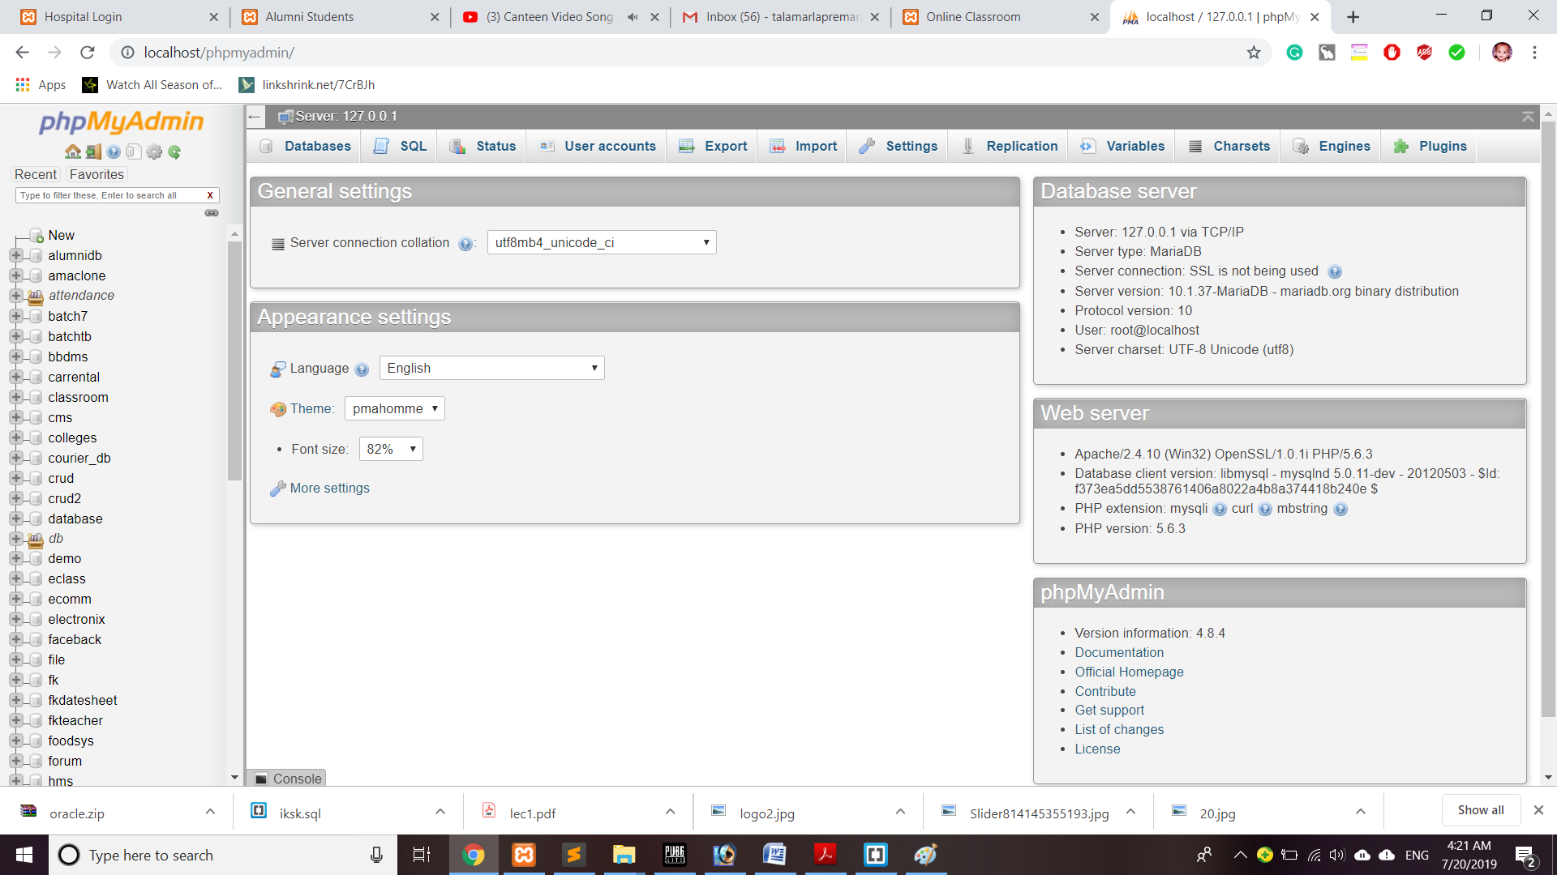

**Fig 6.2**

The first step with phpMyAdmin running is creating a new database. We create a new database by directly executing SQL statements as shown below.The successful execution of the sql querry creates a database ‘student’ with two tables in it. The tables are admin_login and student_information. We also inserted values in the admin table.The screenshot below shows the successful execution of the query thus creation of a database named student.



**Fig 6.3**

Thus we have learned to create a database in MYSQL by executing sql statements. After creating the database and tables we are now ready to use them in our website “Student Information Management System”.

**PROJECT DESCRIPTION**

**Introduction**

CET MANAGEMENT SYSTEM Project can be used by education institutes to maintain the online education and records of students easily. Achieving this objective is difficult using a manual system as the information is scattered, can be redundant and collecting relevant information may be very time consuming. All these problems are solved using this project

The directory structure of the project is as follows:

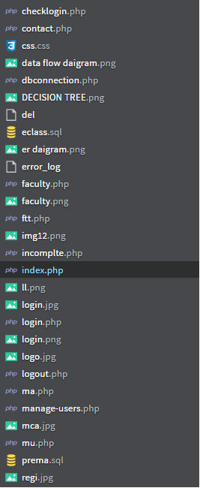

**Fig 6..1 Pages**

**Description of root directory contents**

**Images Directory :** This directory contains the images uploaded by the students during registration process. Supported formats are the .jpg photos.

**Videos Directory:** This directory contains the videos uploaded by the faculty during the uploaded videos process. Supported formats are the MPEG4.

**asd :** Faculty page for editing and delete of students. The Faculty can change details of a student in this page. Through facility of changing the Sname and Batch year etc. Details.

**aupdate-profile:** Faculty Update their student details and Control over the student data. They are also Delete the student from database.

**checklogin:** This is Faculty Login authentication page, it controls the valid username and password then only show the page

**contact:** Details of the Institute address

**dbconnection:** Page for database connectivity. It is used whenever database values are required on the page.

**eclass:** SQL Database

**faculty:** Faculty login with the their creditanals

**ftt:** faculty time table

**index:** Home Page of this project

**login:** Student login with their username and password

**logout:** student and faculty logout with their login details

**ma:** Faculty login and Student login with their username and password to upload or view the material content.

**manage-users:** Faculty login in this module to get all the Student Details with edit and Delete options

**mu:** Faculty login and upload their Materials like pdf, photos etc.

**register:** Student registration and Register their username, admission number, email, password etc.,

**sp:** Student login with their username and password to access their Personal Information.

**sv:** Student login with their credentials to view the uploaded videos.

**tt:** Student login to See their Time Table

**vc:** Student login to see faculty uploaded Videos

**vconfig:** Create Database and Root and username connection with their Data connection Id.

**vcu:** Faculty uploaded videos to their Students

**videos:** SQL Database for Videos

**welcome:** Student Login Homepage

**css.css :** Style Sheets of this Project

**style.css :** Style Sheets of this project

**Description of Database Tables**

* **Eclass**

**Eclass :**

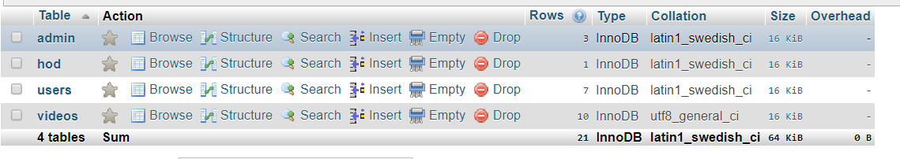

**Admin :**

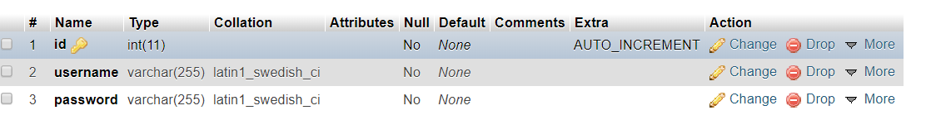

* Id :Stores id for the admin serial no
* Username :Stores id of Faculty
* Password : Stores the password of the Faculty

**HOD:**

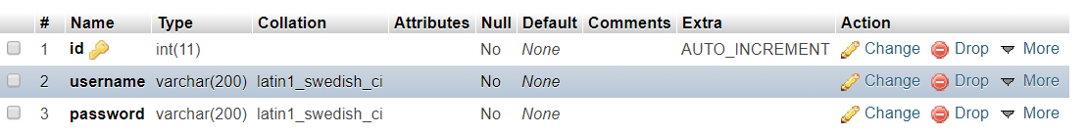

* Id :Stores id for the HOD serial no
* Username :Stores id of HOD
* Password : Stores the password of the HOD

**Users :**

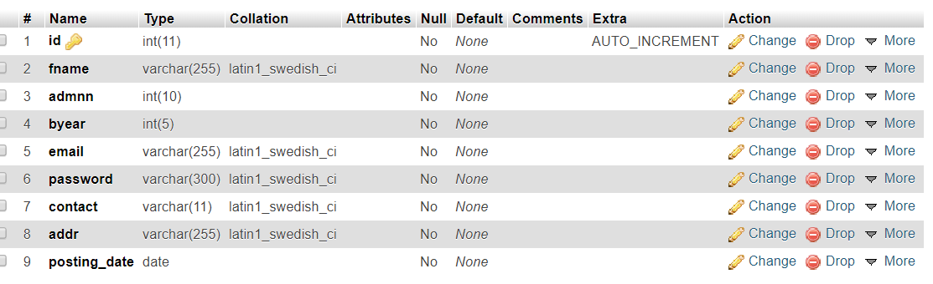

* Id : Stores id for the Student serial no
* Fname : Student registration student name
* Admn : Student Admission Year
* Byear : Student Batch Year
* Email : Student email
* Password :Student Password
* Contact : Student Phone number
* Addr : Student Address
* Posting_date :Student registration ID

**Videos :** 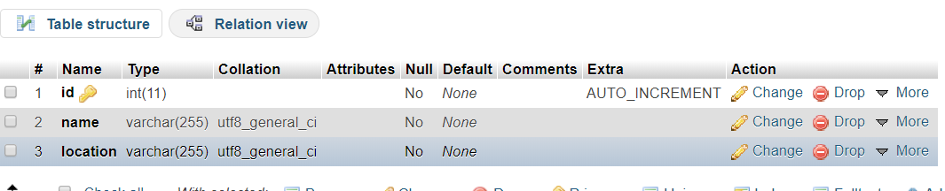

* Id : Stores user id of Videos files
* Name : Stores with that name of Video Name
* Location : Stores within that location of the file.

**Source Code:**

**Index.php**

<!DOCTYPE html>

<html>

<head>

<title>CET MANAGEMENT SYSTEM</title>

<link rel="stylesheet" href="style.css">

<link rel="stylesheet" href="css.css">

</head>

<body>

<header>

<div class="container">

<div id="branding">

<h1><span class="highlight">Online</span> Classes </h1>

</div>

<nav>

<ul>

<li class="current"><a href="index.php">Home</a></li>

<li><a href="login.php">Student Login</a></li>

<li><a href="faculty.php">Faculty Login</a></li>

<li><a href="contact.php">Contact Us...</a></li>

</ul>

</nav>

</div>

</header>

<section id="showcase">

<div class="container">

<h1>CET MANAGEMENT SYSTEM</h1>

<p>Welcome to S V University MCA Department of CET MANAGEMENT SYSTEM Website.</p>

</div>

</section>

<section id="boxes">

<div class="container">

<div class="box">

<img src="regi.png" height="100" width="100">

<br>

<a href="register.php"><img src="register.png" alt="registerimage"></a>

<br>

<h3>New Student Registration</h3>

<p>Till Now You not Registerd CET MANAGEMENT SYSTEM Registration .. Then Register Now.</p>

</div>

<div class="box">

<img src="ll.png" height="100" width="100">

<br>

<a href="login.php"><img src="login.png" alt="loginimage"></a>

<br>

<h3>Student Login</h3>

<p>Already Registed Students Login With their Credentials.</p>

</div>

<div class="box">

<img src="admin.png" height="100" width="100">

<br>

<a href="faculty.php"><img src="faculty.png" alt="facultyimage"></a>

<br>

<h3>Faculty Login</h3>

<p>SVU MCA Dept of HOD and Faculty Login with their Credentials.</p>

</div>

</div>

</section>

<footer>

<p>Copyright to &copy; S V UNiversity MCA Dept. 2019</p>

</footer>

</body>

</html>

**Welcome.php**

<?php session_start(); include( "checklogin.php"); check_login(); ?>

<!DOCTYPE html>

<html>

<head>

<meta charset="utf-8">

<meta name="viewport" content="width=device-width">

<title>CET MANAGEMENT SYSTEM</title>

<link rel="stylesheet" href="style.css">

<link rel="stylesheet" href="css.css">

</head>

<body>

<header>

<div class="container">

<div id="branding">

<h1><span class="highlight">Online</span> Classes </h1>

</div>

<nav>

<ul>

<li class="current"><a href="#">Dear Student : <?php echo $_SESSION['name'];?> </a>

</li>

<li><a href="index.php">Home</a>

</li>

<li><a href="login.php">Student Login</a>

</li>

<li><a href="faculty.php">Faculty Login</a>

</li>

<li><a href="contact.php">Contact Us...</a>

</li>

<li><a href="logout.php">Logout : <?php echo $_SESSION['name'];?> </a>

</li>

</ul>

</nav>

</div>

</header>

<h1 class="heading"> Welcome My Student - <b><?php echo $_SESSION['name'];?></b></h1>

<br>

<div id="btable">

<div id="bt1">

<h1 class="heading"> Student Action </h1>

<button class="button"><span><a href="sp.php"> Student Profile</a> </span>

</button>

<button class="button"><span><a href="vc.php"> Video Classes </a> </span>

</button>

<button class="button"><span><a href="ma.php"> Material </a> </span>

</button>

<button class="button"><span><a href="tt.php">Time Table </a> </span>

</button>

<button class="button"><span><a href="logout.php">Student Logout </a> </span>

</button>

</div>

<div id="bt2">

<h1 class="heading"> How To Use - Online Classes and Benifits </h1>

<h3 class="mb">

<p> S V University M.C.A Dept Introducing to develop one-to-one programs, Allowing students to use their preferred study methods on Reliable Mobile devices and Laptops that are already connected to the MCA Online Classes Portal.</p>

<ul>

<li>Easy to Access</li>

<li>Secure</li>

<li>Uses anytime and Any where </li>

<li>Learning Many Times - Repeatedly </li>

<li>You Can Download Classes or Materilas</li>

</ul>

</h3>

</div>

</div>

</body>

**Faculty.php**

<?php session_start(); include( "dbconnection.php"); if(isset($_POST[ 'login'])) { $adminusername=$_POST[ 'username']; $pass=($_POST[ 'password']); $ret=mysqli_query($con, "SELECT * FROM admin WHERE username='$adminusername' and password='$pass'"); $num=mysqli_fetch_array($ret); if($num>0) { $extra="manage-users.php"; $_SESSION['login']=$_POST['username']; $_SESSION['id']=$num['id']; echo "

<script>

window.location.href = '".$extra."'

</script>"; exit(); } else { $_SESSION['action1']="*Invalid username or password"; $extra="index.php"; echo "

<script>

window.location.href = '".$extra."'

</script>"; exit(); } } ?>

<!DOCTYPE html>

<html>

<head>

<meta charset="utf-8">

<meta name="viewport" content="width=device-width">

<title>CET MANAGEMENT SYSTEM</title>

<link rel="stylesheet" href="style.css">

<link rel="stylesheet" href="css.css">

</head>

<body>

<header>

<div class="container">

<div id="branding">

<h1><span class="highlight">Online</span> Classes </h1>

</div>

<nav>

<ul>

<li class="current"><a href="index.php">Home</a>

</li>

<li><a href="login.php">Student Login</a>

</li>

<li><a href="faculty.php">Faculty Login</a>

</li>

<li><a href="contact.php">Contact Us...</a>

</li>

</ul>

</nav>

</div>

</header>

<section id="login">

<div class="wrap">

<h2> Faculty Login </h2>

<form action="" method="post">

<?php echo $_SESSION[ 'action1'];?>

<?php echo $_SESSION[ 'action1']="" ;?>

<input type="text" name="username" placeholder="Faculty Username" required>

<input type="password" name="password" placeholder="Faculty Password" required>

<input type="submit" name="login" value="Faculty Login">

<input type="reset" value="Reset">

</form>

<script>

$.backstretch("assets/img/login-bg.jpg", {

speed: 500

});

</script>

</div>

</section>

<footer>

<p>Copyright to &copy; S V UNiversity MCA Dept. 2019</p>

</footer>

</body>

</html>

**Asd.php :**

<?php session_start(); include 'dbconnection.php'; include( "checklogin.php"); check_login(); if(isset($_GET[ 'id'])) { $adminid=$_GET[ 'id']; $msg=mysqli_query($con, "delete from users where id='$adminid'"); if($msg) { echo "<script>alert('Data deleted');</script>"; } } ?>

<head>

<meta charset="utf-8">

<meta name="viewport" content="width=device-width">

<title>CET MANAGEMENT SYSTEM</title>

<link rel="stylesheet" href="style.css">

<link rel="stylesheet" href="css.css">

</head>

<style>

.btable th,

td,

tr {

width: 500px;

font-size: 12px;

padding: none;

margin: none;

font-weight: bold;

}

.heading {

padding: none;

margin: none;

}

table.btable {

padding: 5px;

}

</style>

<body>

<header>

<div class="container">

<div id="branding">

<h1><span class="highlight">Online</span> Classes </h1>

</div>

<nav>

<ul>

<li class="current"><a href="#"> HOD of SVU MCA Dept. </a>

</li>

<li><a href="index.php">Home</a>

</li>

<li><a href="login.php">Student Login</a>

</li>

<li><a href="faculty.php">Faculty Login</a>

</li>

<li><a href="contact.php">Contact Us...</a>

</li>

<li><a href="logout.php">Logout Faculty </a>

</li>

</ul>

</nav>

</div>

</header>

<h1 class="heading"> : : WELCOME HOD LOGIN -- - ALL STUDENT DETAILS : :</b></h1>

<br>

<div id="btable">

<div id="bt1">

<h1 class="heading"> HOD Login </h1>

<button class="button"><span><a href="asd.php"> All Student Details </a> </span>

</button>

<button class="button"><span><a href="vcu.php"> Video Classes Upload </a> </span>

</button>

<button class="button"><span><a href="mu.php"> Material Upload </a> </span>

</button>

<button class="button"><span><a href="ftt.php">Faculty Time Table </a> </span>

</button>

<button class="button"><span><a href="logout.php">Faculty Logout </a> </span>

</button>

</div>

<div id="bt2">

<h3 class="mb">

<table class="btable">

<thead>

<tr>

<th>Sno.</th>

<th class="hidden-phone">Student Name </th>

<th> Admission Number </th>

<th> Batch Year</th>

<th> Email Id</th>

<th>Password</th>

<th>Phone Number</th>

<th>Address </th>

<th>Reg. Date</th>

</tr>

</thead>

<tbody>

<?php $ret=mysqli_query($con,"select * from users");

$cnt=1;

while($row=mysqli_fetch_array($ret))

{?>

<tr>

<td>

<?php echo $cnt;?>

</td>

<td>

<?php echo $row['fname'];?>

</td>

<td>

<?php echo $row['admnn'];?>

</td>

<td>

<?php echo $row['byear'];?>

</td>

<td>

<?php echo $row['email'];?>

</td>

<td>

<?php echo $row['password'];?>

</td>

<td>

<?php echo $row['contact'];?>

</td>

<td>

<?php echo $row['addr'];?>

</td>

<td>

<?php echo $row['posting_date'];?>

</td>

<td>

<a href="aupdate-profile.php?uid=<?php echo $row['id'];?>">

<button class="button1"><i>Edit</i></button>

</a>

<a href="amanage-users.php?id=<?php echo $row['id'];?>">

<button class="button1" onClick="return confirm('Do you really want to delete');"><i>Delete</i></button>

</a>

</td>

</tr>

<?php $cnt=$cnt+1; }?>

</tbody>

</table>

</h3>

</div>

</div>

<script>

$(function() {

$('select.styled').customSelect();

});

</script>

</body>

**Vcu.php**

<?php session_start();

include'dbconnection.php';

if(isset($_POST['but_upload'])){

$maxsize = 92428800; // 150MB

$name = $_FILES['file']['name'];

$target_dir = "videos/";

$target_file = $target_dir . $_FILES["file"]["name"];

// Select file type

$videoFileType = strtolower(pathinfo($target_file,PATHINFO_EXTENSION));

// Valid file extensions

$extensions_arr = array("mp4","avi","3gp","mov","mpeg");

// Check extension

if( in_array($videoFileType,$extensions_arr) ){

// Check file size

if(($_FILES['file']['size'] >= $maxsize) || ($_FILES["file"]["size"] == 0)) {

echo "File too large. File must be less than 150MB.";

}else{

// Upload

if(move_uploaded_file($_FILES['file']['tmp_name'],$target_file)){

// Insert record

$query = "INSERT INTO videos(name,location) VALUES('".$name."','".$target_file."')";

mysqli_query($con,$query);

echo "Upload successfully.";

}

}

}else{

echo "Invalid file extension.";

}

}

?>

<!DOCTYPE html>

<html>

<head>

<meta charset="utf-8">

<meta name="viewport" content="width=device-width">

<title>CET MANAGEMENT SYSTEM</title>

<link rel="stylesheet" href="style.css">

<style>

body {

background-image: linear-gradient(rgba(0, 0, 0, 0.5), rgba(0, 0, 0, 0.5)), url(2.3.jpg);

}

#btable {

width: 100%;

height: 500px;

padding-top: 30px;

padding-left: 10px;

padding-bottom: 10px;

}

.btable {

width: 100%;

height: 500px;

padding-top: 30px;

padding-left: 10px;

padding-bottom: 10px;

color: greenyellow;

}

.btable td,

th {

border: 2px solid greenyellow;

}

#bt1 {

width: 20%;

height: 500px;

float: left;

margin-left: 20px;

// border: 5px solid green;

}

#bt2 {

width: 70%;

height: 500px;

float: left;

margin-left: 70px;

// border: 5px solid white;

margin-right: 25px;

}

.heading {

color: greenyellow;

font-family: monospace;

font-display: block;

}

.mb {

color: fuchsia;

font-family: cursive;

text-align: left;

}

.button {

border-radius: 4px;

background-color: #f4511e;

border: none;

color: #FFFFFF;

text-align: center;

font-size: 20px;

padding: 20px;

width: 200px;

transition: all 0.5s;

cursor: pointer;

margin: 5px;

}

.button1 {

border-radius: 4px;

background-color: #f0011e;

border: none;

color: #FFFFFF;

text-align: center;

font-size: 15px;

padding: 10px;

width: 100px;

transition: all 0.5s;

cursor: pointer;

margin: 2px;

}

.button1 a {

text-decoration: none;

}

.button a {

text-decoration: none;

}

.button1 span {

cursor: pointer;

display: inline-block;

position: relative;

transition: 0.5s;

}

.button1 span:after {

content: '00bb';

position: absolute;

opacity: 0;

top: 0;

right: -20px;

transition: 0.5s;

}

.button1:hover span {

padding-right: 25px;

}

.button1:hover span:after {

opacity: 1;

right: 0;

}

.button span {

cursor: pointer;

display: inline-block;

position: relative;

transition: 0.5s;

}

.button span:after {

content: '\00bb';

position: absolute;

opacity: 0;

top: 0;

right: -20px;

transition: 0.5s;

}

.button:hover span {

padding-right: 25px;

}

.button:hover span:after {

opacity: 1;

right: 0;

}

ul {

list-style-type: circle;

padding: 20px;

}

ul li {

margin: 5px;

margin-left: 40px;

}

input[type=submit],

input[type=file] {

background-color: #4CAF50;

color: white;

padding: 12px 20px;

border: none;

border-radius: 4px;

cursor: pointer;

}

input[type=submit],

input[type=file]:hover {

background-color: #23bb89;

}

</style>

</head>

<body>

<header>

<div class="container">

<div id="branding">

<h1><span class="highlight">Online</span> Classes </h1>

</div>

<nav>

<ul>

<li class="current"><a href="#"> HOD of SVU MCA Dept. </a></li>

<li><a href="index.php">Home</a></li>

<li><a href="login.php">Student Login</a></li>

<li><a href="faculty.php">Faculty Login</a></li>

<li><a href="contact.php">Contact Us...</a></li>

<li><a href="logout.php">Logout Faculty </a></li>

</ul>

</nav>

</div>

</header>

<h1 class="heading"> : : WELCOME HOD LOGIN : :</b></h1>

<br>

<div id="btable">

<div id="bt1">

<h1 class="heading"> HOD Login</h1>

<button class="button"><span><a href="asd.php"> All Student Details </a> </span></button>

<button class="button"><span><a href="vcu.php"> Video Classes Upload </a> </span></button>

<button class="button"><span><a href="mu.php"> Material Upload </a> </span></button>

<button class="button"><span><a href="ftt.php">Faculty Time Table </a> </span></button>

<button class="button"><span><a href="logout.php">Faculty Logout </a> </span></button>

</div>

<div id="bt2">

<h1 class="heading"> Faculty Upload Video Classes </h1>

<h3 class="mb">

<a class="button " href="sv.php">Up Loaded Videos</a><br>

<center>

<form method="post" action="" enctype='multipart/form-data'>

<input type='file' name='file' value='Upload Videos' />

<input type='submit' value='Upload' name='but_upload'>

</form>

<h3> Faculty Upload the Class Videos </h3>

</center>

</h3>

</div>

</div>

<script>

$(function() {

$('select.styled').customSelect();

});

</script>

</body>

**Css.css**

body {

background-image: linear-gradient(rgba(0, 0, 0, 0.5), rgba(0, 0, 0, 0.8)), url(images/20.jpg);

background-size: cover;

background-position: center;

text-align: center;

min-height: 400px;

}

.heading {

color: greenyellow;

font-family: monospace;

font-display: block;

}

.mb {

color: fuchsia;

font-family: cursive;

text-align: left;

}

table,

th,

td,

tr {

border: 2px solid gray;

width: 100%;

}

table td {

margin: 10px;

padding: 10px;

width: auto;

}

#btable {

width: 100%;

height: 500px;

padding-top: 10px;

padding-left: 10px;

padding-bottom: 10px;

}

#bt1 {

width: 20%;

height: 500px;

float: left;

margin-left: 20px;

// border: 5px solid green;

}

#bt2 {

width: 70%;

height: 500px;

float: left;

margin-left: 70px;

// border: 5px solid white;

margin-right: 25px;

}

.btable {

width: 100%;

height: 500px;

padding-top: 30px;

padding-left: 10px;

padding-bottom: 10px;

color: greenyellow;

}

.btable td,

th {

border: 2px solid greenyellow;

}

.button {

border-radius: 4px;

background-color: #f4511e;

border: none;

color: #FFFFFF;

text-align: center;

font-size: 20px;

padding: 20px;

width: 200px;

transition: all 0.5s;

cursor: pointer;

margin: 5px;

}

.button1 {

border-radius: 4px;

background-color: #f0011e;

border: none;

color: #FFFFFF;

text-align: center;

font-size: 15px;

padding: 10px;

width: 100px;

transition: all 0.5s;

cursor: pointer;

margin: 2px;

}

.button a {

text-decoration: none;

}

.button1 a {

text-decoration: none;

}

.button span {

cursor: pointer;

display: inline-block;

position: relative;

transition: 0.5s;

}

.button1 span {

cursor: pointer;

display: inline-block;

position: relative;

transition: 0.5s;

}

.button span:after {

content: '\00bb';

position: absolute;

opacity: 0;

top: 0;

right: -20px;

transition: 0.5s;

}

.button1 span:after {

content: '\00bb';

position: absolute;

opacity: 0;

top: 0;

right: -20px;

transition: 0.5s;

}

.button:hover span {

padding-right: 25px;

}

.button:hover span:after {

opacity: 1;

right: 0;

}

.button1:hover span {

padding-right: 25px;

}

.button1:hover span:after {

opacity: 1;

right: 0;

}

ul {

list-style-type: circle;

padding: 20px;

}

ul li {

margin: 5px;

margin-left: 40px;

}

input[type=submit],

input[type=file] {

background-color: #4CAF50;

color: white;

padding: 12px 20px;

border: none;

border-radius: 4px;

cursor: pointer;

}

input[type=submit],

input[type=file]:hover {

background-color: #23bb89;

}

video {

float: center;

}

**Style.css**

body {

font: 15px/1.5 Arial, Helvetica, sans-serif;

padding: 0;

margin: 0;

background-size: cover;

background-position: center;

text-align: center;

min-height: 400px;

}

/* Global */

.container {

width: auto;

margin: 20px;

overflow: hidden;

}

ul {

margin: 0;

padding: 0;

}

/* Header **/

header {

background: #12404a;

color: #ffffff;

padding-top: 12px;

min-height: 70px;

border-bottom: #e8491d 3px solid;

}

header a {

color: #ffffff;

text-decoration: none;

text-transform: uppercase;

font-size: 16px;

}

header li {

float: left;

display: inline;

padding: 0 20px 0 20px;

}

header #branding {

float: left;

}

header #branding h1 {

margin: 0;

}

header nav {

float: right;

margin-top: 10px;

}

header .highlight,

header .current a {

color: red;

font-weight: bold;

}

header a:hover {

color: red;

font-weight: bold;

}

/* Showcase */

#showcase {

text-align: center;

color: #ffffff;

}

#showcase h1 {

margin-top: 100px;

font-size: 55px;

margin-bottom: 10px;

font-variant: small-caps;

font-family: Bookman;

}

#showcase p {

font-size: 20px;

font-variant: small-caps;

font-weight: bold;

}

#showcase h1:hover {

margin-top: 100px;

font-size: 60px;

margin-bottom: 10px;

color: orangered;

font-family: monospace;

font-variant: small-caps;

}

#showcase p:hover {

font-size: 22px;

color: greenyellow;

font-variant: small-caps;

}

#login .wrap {

max-width: 400px;

border-radius: 20px;

margin: auto;

background: rgba(0, 0, 0, 0.5);

box-sizing: border-box;

padding: 40px;

color: #fff;

margin-top: 50px;

margin-bottom: 50px;

}

#login h2 {

text-align: center;

}

#login h2:hover {

text-align: center;

color: gold;

}

#login input[type=text],

input[type=password],

input[type=email] {

width: 100%;

box-sizing: border-box;

padding: 12px 5px;

background: rgba(0, 0, 0, 0.10);

outline: none;

border: none;

border-bottom: 1px dotted #fff;

color: gold;

border-radius: 5px;

margin: 5px;

font-weight: bold;

}

#login input[type=text],

input[type=password],

input[type=email]:hover {

color: greenyellow;

}

#login input[type=submit] {

width: 100%;

box-sizing: border-box;

padding: 10px 0;

margin-top: 30px;

outline: none;

border: none;

background: #60adde;

opacity: 0.7;

border-radius: 20px;

font-size: 20px;

color: #fff;

}

#login input[type=reset] {

width: 25%;

box-sizing: border-box;

padding: 10px 0;

margin-top: 30px;

outline: none;

border: none;

background: #259600;

opacity: 0.7;

border-radius: 20px;

font-size: 20px;

color: #fff;

}

#login button {

float: right;

width: 25%;

box-sizing: border-box;

padding: 10px 0;

margin-top: 30px;

outline: none;

border: none;

background: #259600;

opacity: 0.7;

border-radius: 20px;

font-size: 20px;

color: #fff;

text-decoration: none;

}

#login button a {

text-decoration: none;

color: #fff;

}

#login input[type=submit]:hover {

background: #003366;

opacity: 0.7;

}

/* Boxes */

#boxes {

margin-top: 20px;

}

#boxes .box {

float: left;

text-align: center;

width: 30%;

padding: 10px;

color: white;

font-style: oblique;

}

#boxes .box img {

width: 90px;

}

#boxes .box img:hover {

width: 150px;

height: 100px;

border-radius: 50px;

}

#boxes .box h3 {

font-family: verdana;

font-weight: bold;

}

#boxes .box p {

font-family: courier;

font-weight: bold;

}

#boxes .box h3:hover {

font-family: verdana;

color: gold;

font-weight: bold;

font-variant: small-caps;

}

#boxes .box p:hover {

font-family: courier;

color: gold;

font-weight: bold;

font-variant: small-caps;

}

/* Main-col */

article#main-col {

float: left;

width: 65%;

}

/* Services */

ul#services li {

list-style: none;

padding: 20px;

border: #cccccc solid 1px;

margin-bottom: 5px;

background: #e6e6e6;

}

footer {

padding: 5px;

margin-top: 15px;

color: #ffffff;

background-color: slategray;

text-align: center;

}

/* Media Queries */

@media(max-width: 768px) {

header #branding,

header nav,

header nav li,

#boxes .box,

article#main-col,

header {

padding-bottom: 20px;

}

#showcase h1 {

margin-top: 40px;

}

}

**Logout.php**

<?php

session_start();

$_SESSION['login']=="";

session_unset();

$_SESSION['action1']="You have logged out successfully..!";

?>

<script language="javascript">

document.location="index.php";

</script>

**Eclass.sql**

SET SQL_MODE = "NO_AUTO_VALUE_ON_ZERO";

SET AUTOCOMMIT = 0;

START TRANSACTION;

SET time_zone = "+00:00";

--

-- Database: `eclass`

--

-- --------------------------------------------------------

--

-- Table structure for table `admin`

--

CREATE TABLE `admin` (

`id` int(11) NOT NULL,

`username` varchar(255) NOT NULL,

`password` varchar(255) NOT NULL

) ENGINE=InnoDB DEFAULT CHARSET=latin1;

--

-- Dumping data for table `admin`

--

INSERT INTO `admin` (`id`, `username`, `password`) VALUES

(1, 'admin', '338a4d9db0d484fdf4781fd9c25aeec3'),

(0, 'mcahod', 'mcahod'),

(1, 'mcahod', '338a4d9db0d484fdf4781fd9c25aeec3');

-- --------------------------------------------------------

--

-- Table structure for table `hod`

--

CREATE TABLE `hod` (

`id` int(11) NOT NULL,

`username` varchar(200) NOT NULL,

`password` varchar(200) NOT NULL

) ENGINE=InnoDB DEFAULT CHARSET=latin1;

--

-- Dumping data for table `hod`

--

INSERT INTO `hod` (`id`, `username`, `password`) VALUES

(1, 'mcahod', 'mcahod');

-- --------------------------------------------------------

--

-- Table structure for table `users`

--

CREATE TABLE `users` (

`id` int(11) NOT NULL,

`fname` varchar(255) NOT NULL,

`admnn` int(10) NOT NULL,

`byear` int(5) NOT NULL,

`email` varchar(255) NOT NULL,

`password` varchar(300) NOT NULL,

`contact` varchar(11) NOT NULL,

`addr` varchar(255) NOT NULL,

`posting_date` date NOT NULL

) ENGINE=InnoDB DEFAULT CHARSET=latin1;

--

-- Table structure for table `videos`

--

CREATE TABLE `videos` (

`id` int(11) NOT NULL PRIMARY KEY AUTO_INCREMENT,

`name` varchar(255) NOT NULL,

`location` varchar(255) NOT NULL

) ENGINE=InnoDB DEFAULT CHARSET=utf8;

--

-- Dumping data for table `users`

--

INSERT INTO `users` (`id`, `fname`, `admnn`, `byear`, `email`, `password`, `contact`, `addr`, `posting_date`) VALUES

(0, 'zerxdctfbhjk', 895231, 7845132, 'ppp@gmail.com', '852', '874152', 'dtrfygyuioimk,l', '2019-03-23'),

(0, 'dtrfyguhjnk', 9856320, 8745132, 'jhksj@gmail.com', '865312', '895623', 'cfghjbkl m,', '2019-03-23'),

(0, 'talamarla', 20174852, 2017, 'newone@gmail.com', '123456', '8074158222', 'Tirupathi, Sv Unversity, Near Library. 517502', '2019-03-23'),

(0, 'MCA', 1994, 2019, 'mca@gmail.com', 'thisisme', '80741582220', 'India,Andhra Pradesh, Delhi , Canadfa, 517501.', '2019-03-23'),

(0, 'Talamarla Premanath', 60117163, 2017, 'talamarlapremanath143@gmail.com', '123', '8074158222', 'Tirupathi, Anantapur , India, Andhra Pradesh ,517501', '2019-03-23');

--

-- Indexes for dumped tables

--

--

-- Indexes for table `hod`

--

ALTER TABLE `hod`

ADD PRIMARY KEY (`id`);

--

-- AUTO_INCREMENT for dumped tables

--

--

-- AUTO_INCREMENT for table `hod`

--

ALTER TABLE `hod`

MODIFY `id` int(11) NOT NULL AUTO_INCREMENT, AUTO_INCREMENT=2;

COMMIT;

**SCREENSHOTS**

**Home Page:**

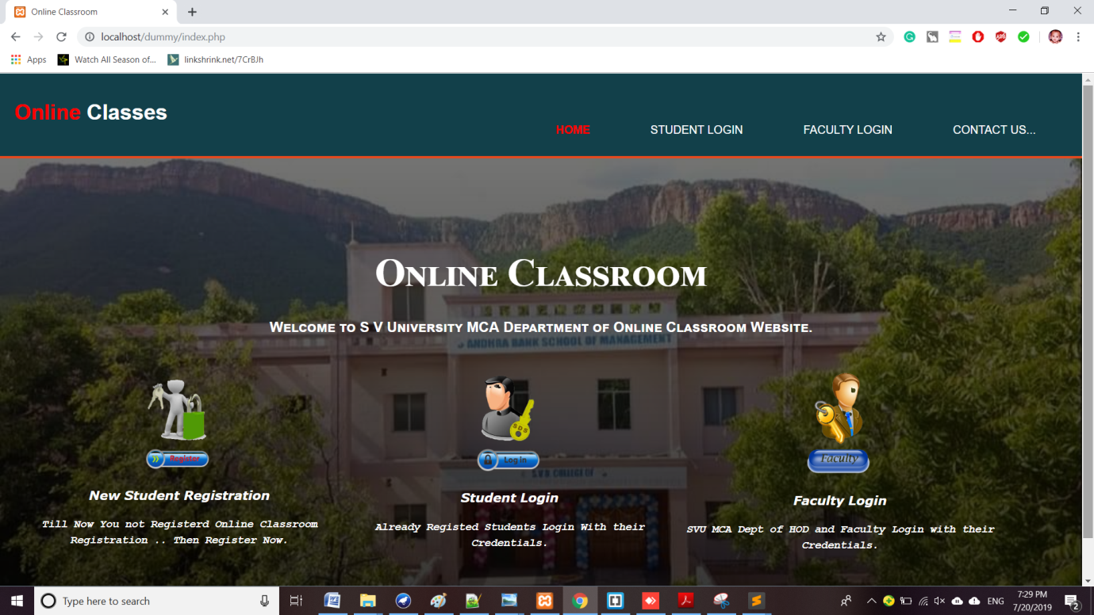

**Fig 9.1 Pages**

**Student Login :**

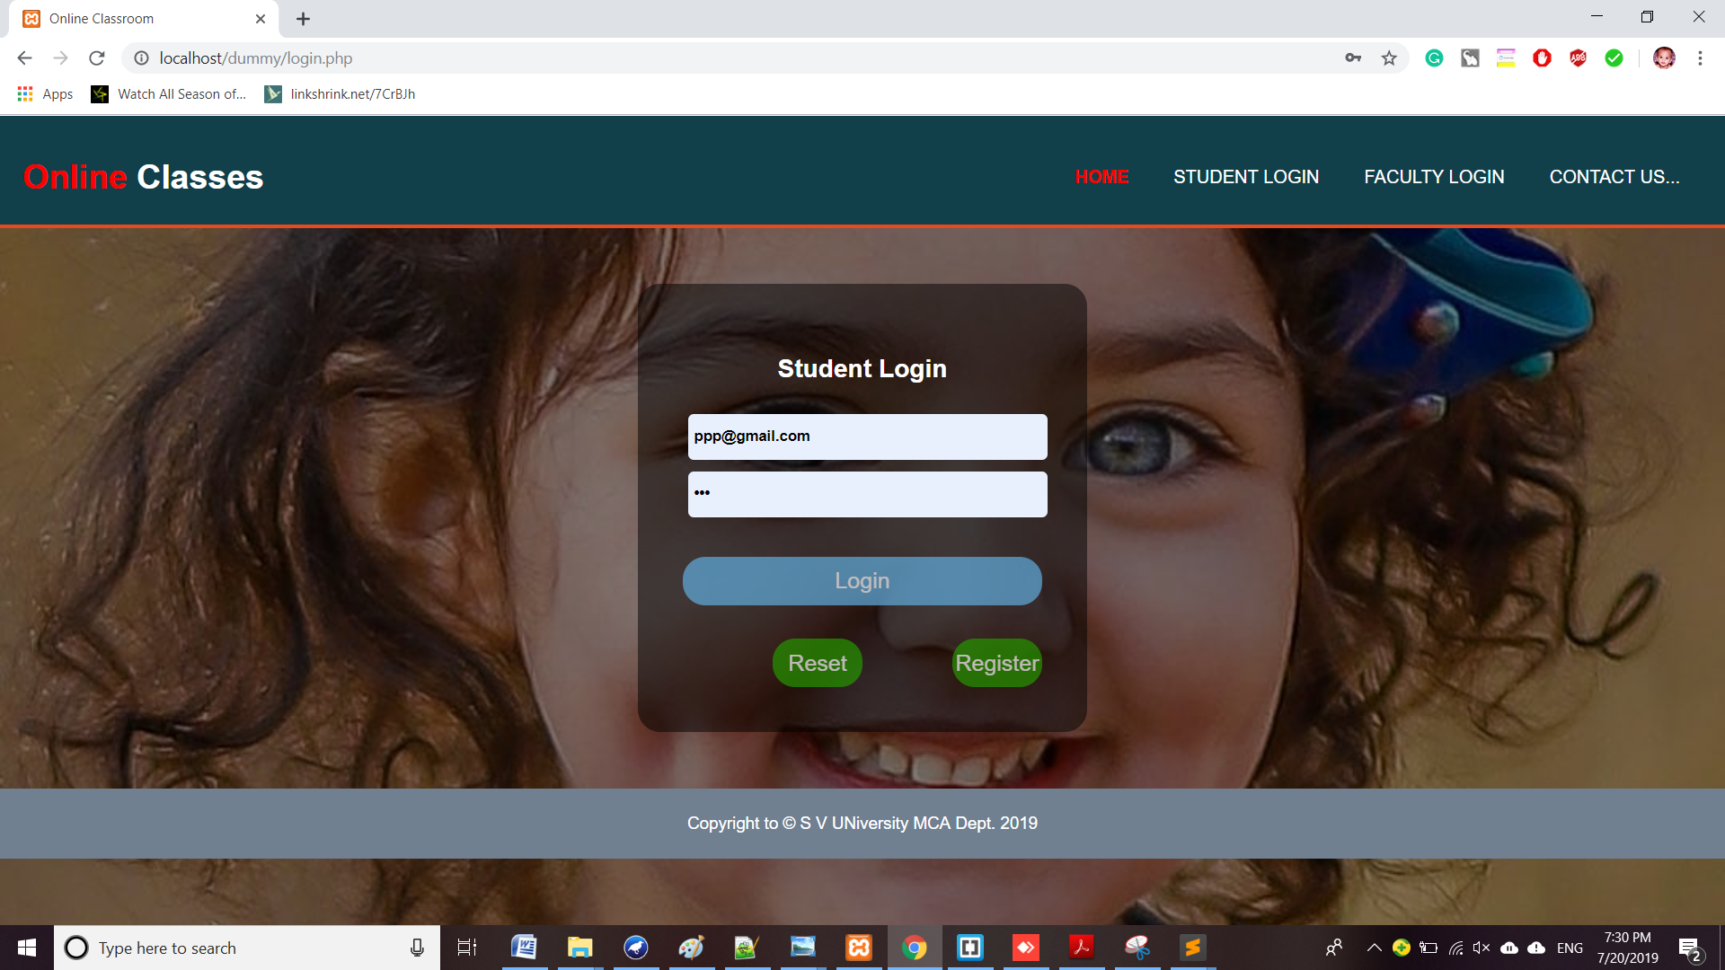

**Fig 9.1 Pages**

**Faculty Login :**

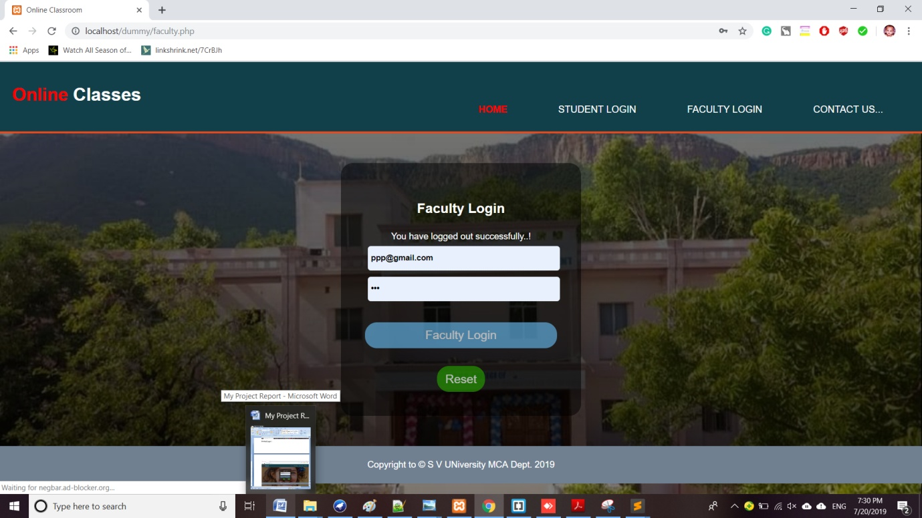

**Fig 9.3 Pages**

**Faculty Login Time Table**

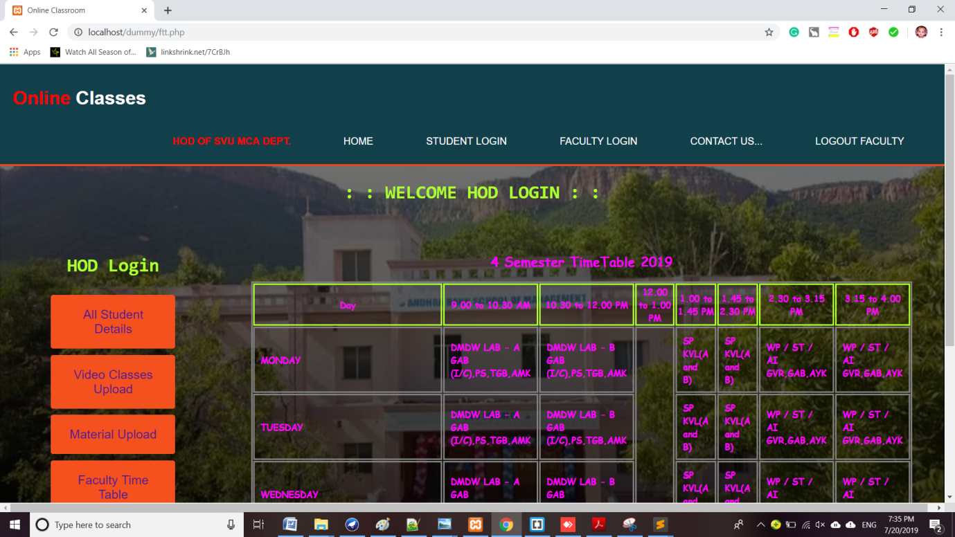

**Fig 9.4 Pages**

**Faculty Login – All Students**

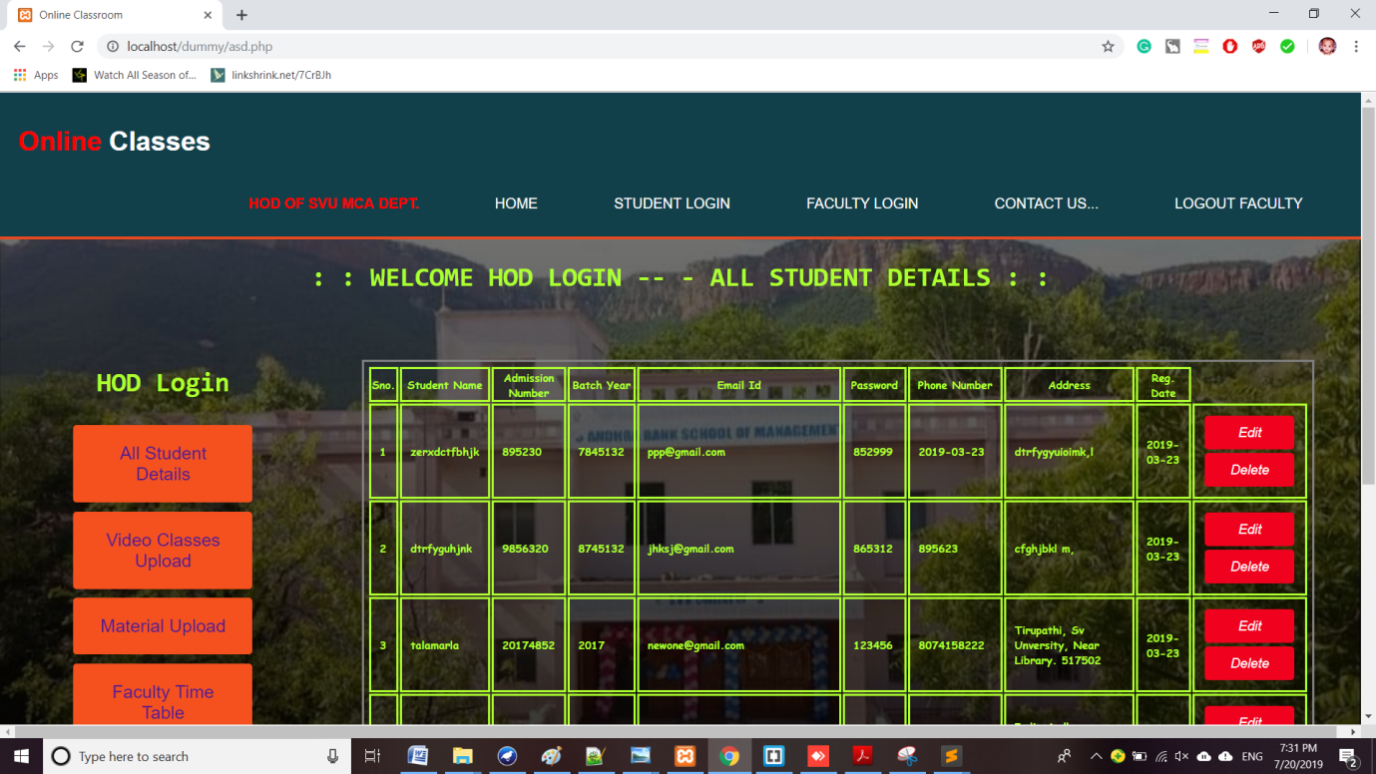

**Fig 9.5 Pages**

**Student Login – Material View**

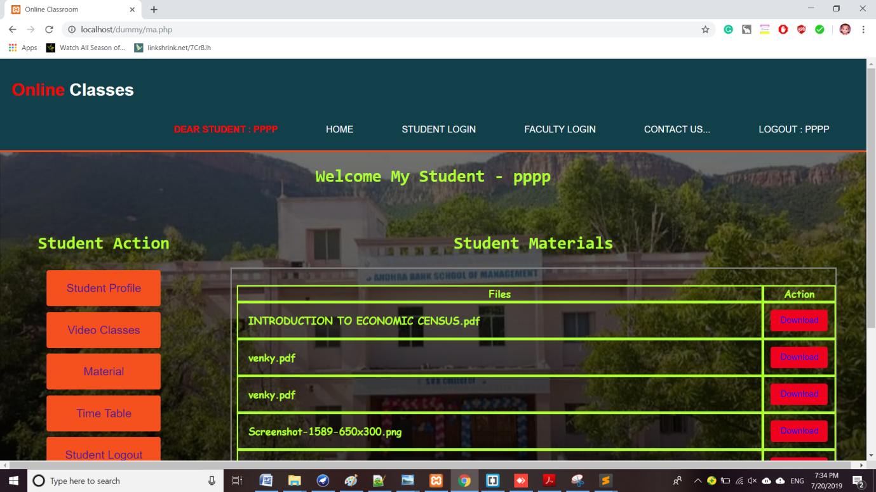

**Fig 9.5 Pages**

**Student – Login Access Videos**

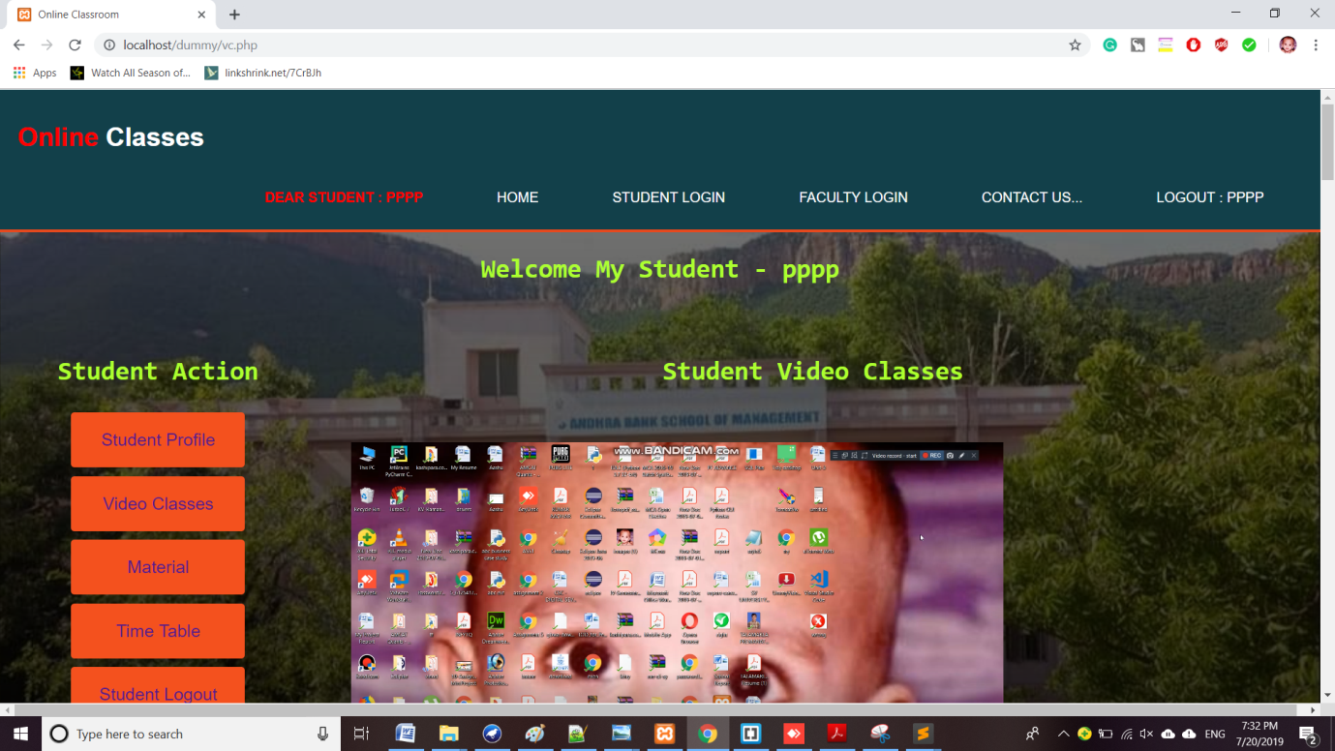

**Fig 9.6 Pages**

**Contact Us :**

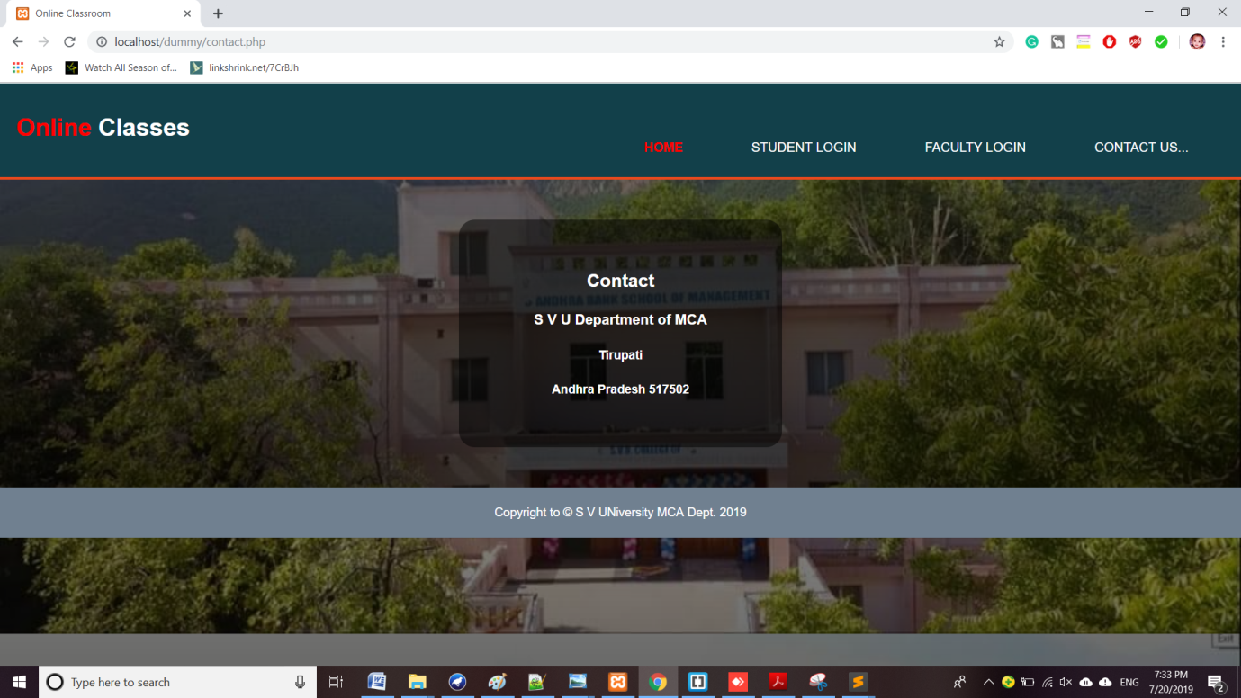

**Fig 9.7 Page**

**Scope of the Project**

* CET MANAGEMENT SYSTEM Project can enhanced to repeat Viedo classes with Online Learning Modules.
* Students help define your eLearning course
* help keep your planning eLearning strategies on track
* be in line with educational philosophy
* help define your eLearning assessment
* tell the learner exactly what to expect
* Online Videos Uploaded added
* Online Materials’ Added Successfully Like Pdf, Png,word etc.
* Easy to Access it.

**Bibliography**

* W3.schools.com
* Nptel website
* The Joy of PHP Programming: A Beginner’s Guide – by Alan Forbes
* HTML & CSS: Design and Build Web Sites
* Book by Jon Duckett